Racial Equity At Pathfinder:
Understanding The Needs
Of Our Community

April 6, 2021

By Pathfinder’s Family-Based Racial Equity Committee

Table of Contents

An Open Letter 2
Introduction 3
Methodology 4
Survey Results 4
A. Feel Welcomed 5
B. Feel Belonging 6
C. Feel Represented 7
D. Opportunity For Cultural Identity to be Represented, Shared, or Celebrated 8
E. Microaggressions 9
F. Macroaggressions 10
G. Taking Action 11
H. Priorities for Future Action 12
Observations 13
Recommended Actions 13
Acknowledgments 14
Appendix A - Feel Welcomed 15
Appendix B - Feel Belonging 16
Appendix C - Feel Represented 17
Appendix D - Opportunity For Cultural Identity to be Represented, Shared, or Celebrated 18
Appendix E - Microaggressions 19
Appendix F - Macroaggressions 22
Appendix G - Taking Action 24
Appendix H - Priorities for Future Action 25
Appendix I - Demographic Data for Schools in Seattle 27
Appendix J - Racial Equity Questionnaire 29
Appendix K - Glossary of Terms Related to Racism 31

Open Letter
April 5, 2021

Dear Pathfinder families, staff, and students,

Inspired by the resurgence of the Black Lives Matter movement after the deaths of George Floyd and Breonna Taylor in the summer of 2020, a small group of Pathfinder parents came together to discuss anti-racism efforts in the Pathfinder community. The result was the creation of Pathfinder's first Racial Equity Committee (REC). REC was formed as an all-volunteer, family-based committee dedicated to addressing racial equity issues where we find them: first in ourselves and our families, but also as those issues are experienced by our students, in our classrooms, among our parents, at our school.

As we write to you today, the trial of the former Minneapolis police officer charged with the killing of George Floyd is ongoing. For those watching, the testimony is wrenching; it is clear that the pain of that day still reverberates in those who witnessed it. In a way, we were all witnesses and, in a sense, we have all felt that pain. And yet George Floyd’s homicide is but one of the many public tragedies that occurred in the last year because of, and sometimes in the name of, racial animus. Each one these events remind us, in case we had forgotten, that racism left unchecked can be a lethal force in American life. They may have felt for you, as they have for us in recent days, like fresh waves of cruelty, each one just as menacing and unstoppable as the one before.

As REC, we believe that sustained action against hate, bigotry, and racism starts small, even if the stakes feel impossibly high. We believe in simple acts of kindness, in expressions of sensitivity and concern for friends and strangers alike. We believe that turning back a rising tide of intolerance and inequity requires attention to the places and communities where we spend our day-to-day lives. We believe in starting here: with the community at Pathfinder K-8, in West Seattle, Washington, where we all live and learn, work and play, together.

As REC, we are here to listen to those who may not have been heard before. We are here to amplify our voices together. We are here to seek a deeper understanding of ourselves and our school community. We are here to advocate and to seek accountability. We are here to support and celebrate the diverse families and cultures at Pathfinder. We are here to hope and build trust. We are here because we believe racism is intolerable but not invincible, and because we believe that we can do more, do better, together.

REC’s mission is to create a self-sustaining, anti -racist culture at Pathfinder. We draw our inspiration from Seattle author Ijeoma Oluo’s call to action: “The beauty of anti-racism is that you don’t have to pretend to be free of racism to be an anti-racist. Anti-racism is the commitment to fight racism wherever you find it, including in yourself. And it’s the only way forward.” This report represents a first step on this journey. We invite you to join us on the way forward -- in reflection, understanding, and action.

In solidarity,
-REC-

[Veena Prasad] [Jamelia Alnajjar] [Becky Greenberg]

Introduction

Pathfinder K-8 is a West Seattle public option school located on the traditional lands of the first people of Seattle, the Duwamish People past and present. The school was founded in 1992 and is “committed to expeditionary learning and environmental education”. Pathfinder is different from other public schools in that students enroll based on family choice -- students either enroll because they are in the geographical zone of the school or because they are able to gain admittance through a lottery system. According to the Washington Office of Superintendent of Public Instruction (WA OSPI), there are currently 492 students enrolled in the school. The WA OSPI website shows the student racial demographic breakdown as follows: 3.5% Asian, 3.3% Black/African American, 10.6% Hispanic/Latino of any race, 13.8% of two or more races, and 68.5% White. In comparison, neighboring option school Louisa Boren STEM K-8 has a much more diverse student body. See Appendix I for demographic information for all schools in Seattle, Pathfinder, and Louisa Boren.

About this Report
The purpose of this report is to better understand the racial equity needs of the Pathfinder community and to deepen its engagement with racial equity issues. This report is based on responses to the inaugural racial equity questionnaire prepared by REC and circulated to the Pathfinder community in December 2020 (see Appendix J). This inaugural questionnaire asked Pathfinder families to report about their experiences during the 2019-2020 school year. REC’s questionnaire is the first of its kind at Pathfinder because, unlike other surveys conducted by the district, it focuses on the lived experiences of families in the Pathfinder community. REC intends to administer this racial equity questionnaire on an annual basis going forward. REC’s goal is to produce concrete, actionable data about the racial equity needs of the Pathfinder community annually, and to use the data to create change at the systemic and individual level.

REC was not able to address all of the issues that were raised in response to the inaugural questionnaire in this report. Certain important issues at Pathfinder are not analyzed in this report because they fall outside the scope of REC’s racial equity work, or because REC as a committee of all-volunteer parents did not have the capacity to take them on. These issues are no less worthy of discussion. For example, REC received several comments on topics including economic inequality, class and class privilege, bullying arising for reasons other than race, ableism, neurodiversity, and differential treatment of students and families receiving special education services. REC acknowledges that these are critical issues that require additional attention in the Pathfinder community. REC invites the Pathfinder community to explore these issues in greater depth and welcomes any additional parent leadership on these important matters. REC whole-heartedly supports any such efforts.

In this report, all race categories and groupings have been capitalized. In the body of the report, racial categories and groupings have been spelled out. On graphs and charts, however, abbreviations have been used due to space constraints.

Definitions for commonly used terms like racism and equity are included in a glossary in Appendix K.

Methodology

Terminology
Families of Color (FOC) - This designation was used for families where all members are people of color, even if they are not of the same race. This report uses the abbreviation “FOC” in several places including graphs where space is limited.
Multi-Racial Families (MRF) - This designation was used for families that include more than one race with one of them being White. This report uses the abbreviation “MRF” in several places including graphs where space is limited.
White Families (WF) - This designation was used for families where all members are White. This report uses the abbreviation “WF” in several places including graphs where space is limited.

Sample Size (n)
REC received 135 complete responses to REC’s questionnaire. For purposes of analyzing the racial equity implications of these responses, we have combined the samples into two groupings of roughly equal size:
- Families of Color and Multi-Racial Families with a combined n = 53
- White Families with n = 82

“No Opinion” Responses
The norm in most survey analyses is to exclude “no opinion” responses and recalculate the sample size. However, since this survey’s focus was racial equity and responses to some questions had such a high rate of “no opinion” responses, we decided to complete the analysis without excluding “no opinion” responses.

Anonymity
REC’s questionnaire did not collect names or contact information of respondents. In addition, REC has made every possible effort to preserve anonymity and remove identifying information. Comments that included even somewhat identifiable information were not used unless a respondent specifically gave permission. In a few cases, identifying information like names or specific racial or ethnic groups was replaced with “_____” in order to preserve anonymity.

Survey Results

Sections
The following sections A through H, show the key results and observations for each topic in the survey. More detailed graphs corresponding to the distribution of answers for each question can be found in the corresponding section in the appendix.

Comments
Summary tables of comments are made available in the corresponding appendices. Where possible, selected comments or parts of comments have been included verbatim in the main sections of the report to provide a qualitative sense of the results or to add a new dimension to the data.
A. Feel Welcomed

Q Do you and your family feel welcomed? In the parent community, student community, by teachers, by school administration

Key Points
- A majority of families feel welcomed by parents, teachers, students, and school administration
- A majority of families feel most welcomed by teachers and least welcomed by the school administration
- Families of Color and Multi-Racial Families feel less welcomed in each category as compared to White Families
- Families of Color and Multi-Racial Families feel most welcomed by teachers and least welcomed by other parents

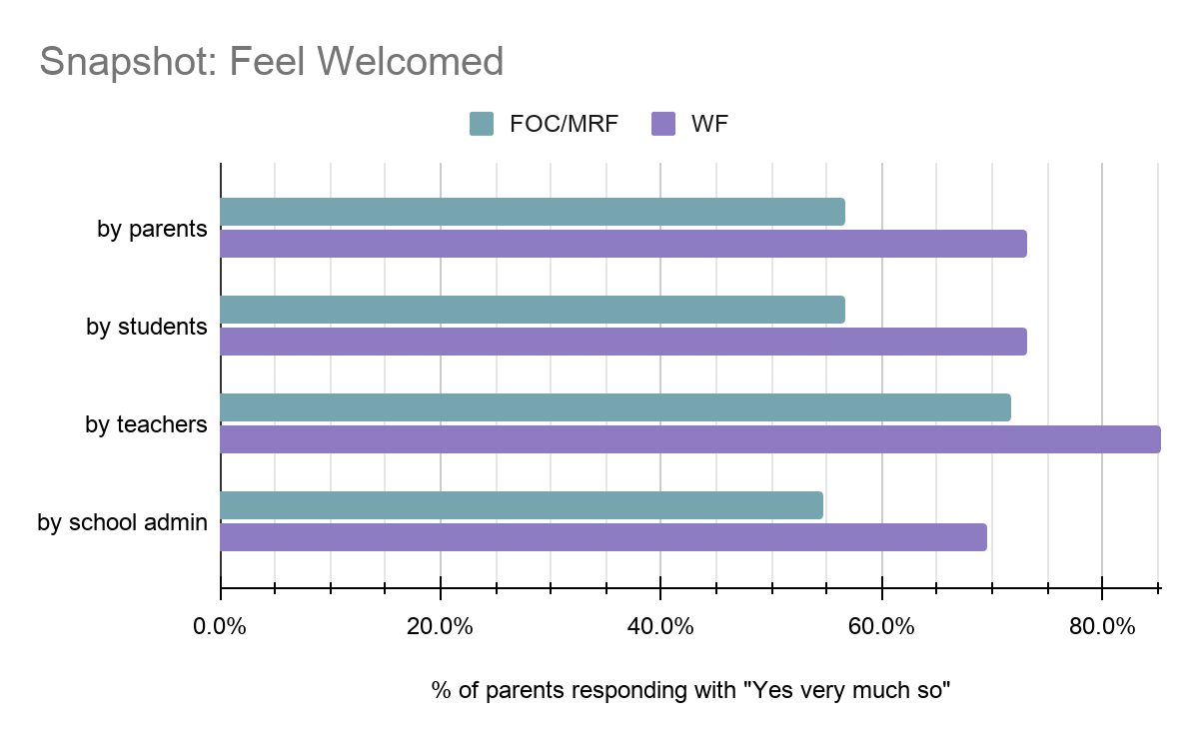
For detailed graphs, see Appendix A.

Comments from the Community

From a Family of Color: “Teacher _______, made us feel welcome and invited parents to share cultural presentations.”

From a Multi-Racial Family: “witnessed what seemed like a disparaging comment about a parent's hard-to-pronounce name during jump start week.”

B. Feel Belonging
Q Do you and your family feel like you belong? In the parent community, student community, with teachers, with school administration

Key Points
- A majority of families feel some or very much belonging in interactions with teachers, students, other parents, and school administration
- A majority of families feel most belonging in interactions with teachers and least belonging in interactions with other parents
- Families of Color and Multi-Racial Families feel significantly less belonging in each category as compared to White Families
- Families of Color and Multi-Racial Families feel most belonging in interactions with teachers and least belonging in interactions with other parent
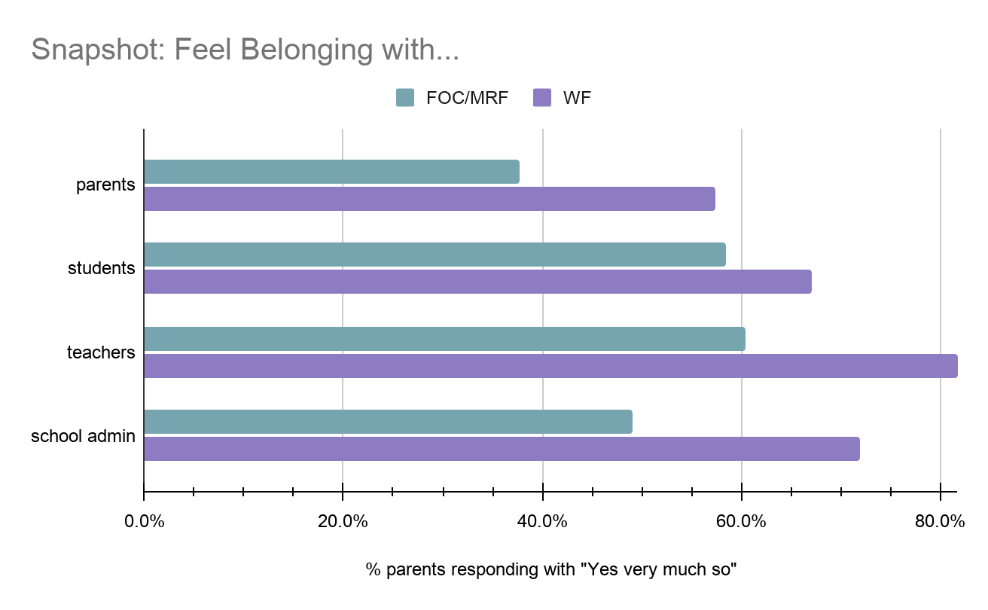
For detailed graphs, see Appendix B.

Comments from the Community
From a Multi-Racial Family: “...feeling more like a foreigner/immigrant than American or part of the community.”

From a White Family: “Since we are white, we are kind of always included by default in American stuff.”

C. Feel Represented
Q Does your family feel racially and culturally represented through the following at Pathfinder? Entrance hallway, books in classroom, books in library, in the curriculum, school events, PTSA events

Key Points
- A supermajority (more than 66%) of White Families feel somewhat or very represented in all categories .
- Families of Color and Multi-Racial Families feel much less (40-55%) represented in each category as compared to White Families
- Families of Color and Multi-Racial Families feel most represented in library books and least represented at PTSA events and curriculum
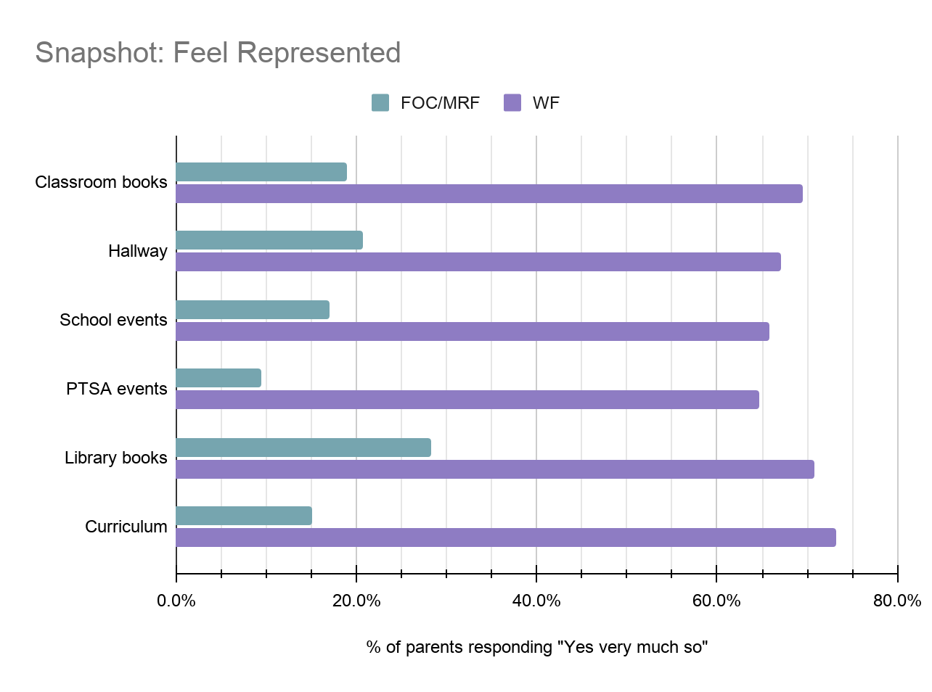
- A majority or a near majority of Families of Color and Multi-Racial Families feel neutral, not much, or not at all represented in all categories

For detailed graphs, see Appendix C.

Comments from the Community
From a Multi-Racial Family: “It's mostly just an absence of any representation of _______ culture and very little curriculum addressing systemic racism.”
From a White Family: “We are white and in the dominant group so our identity is over-represented. Would like to see more communities of color represented.”
From a White Family: “The school is by default set up to make us feel seen and known. As a Jewish family, I don't always feel seen (certainly not on wreath making night) and certainly not celebrated--but more because Pathfinder seems to have taken the stance not to celebrate most anything cultural (e.g. Halloween, anything religious, etc.).

Q Did you family have an opportunity to have your cultural identity acknowledged, shared, and celebrated
D. Opportunity For Cultural Identity to be Represented, Shared, or Celebrated

Key Points
- A majority of Families of Color and Multi-Racial Families reported “no opportunity” or “don’t know” when asked whether they have had an opportunity to have their cultural identity represented, shared, or celebrated
- Even among White families, roughly 1 out 6 families reported “no opportunity” to have their cultural identity celebrated. Since a few comments mentioned Jewish holidays, we believe this may be partly due to the experience of Jewish families not having opportunities to celebrate their special events
- A majority of White Families reported “no opinion” or “don’t know” when asked whether they have had an opportunity to have their cultural identity represented, shared, or celebrated. In the comments, there were several White Families who acknowledged being part of the dominant white culture
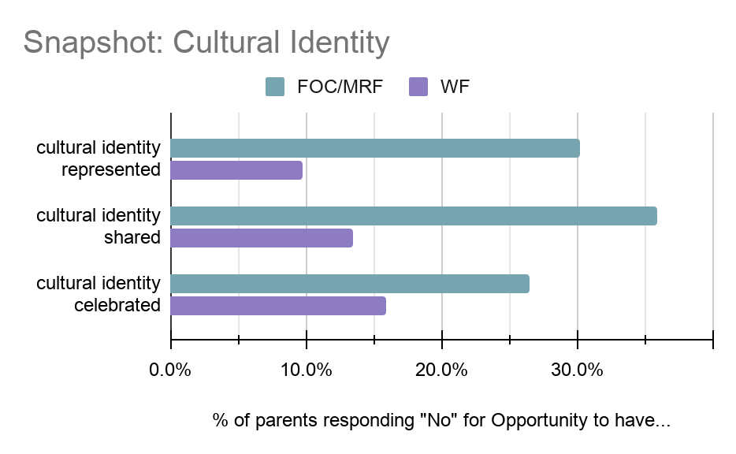
For detailed graphs and comments summary, see Appendix D.

Comments from the Community
From a White Family: “We are white, so ours is part of the dominant culture which is always centered.”

From a White Family: “With Roger’s Monday morning meetings and the Chinese class, my children have some exposure. I would like to see more African American, Asian and Indian influence also.”

From a Multi-Racial Family: “I think instead of not celebrating holidays we should celebrate ALL of the holidays. This is a beautiful way to teach empathy and understanding of their fellow students.“
E. Microaggressions

Q Did any member of your family experience, witness or commit a microaggression in the school year 2019-2020?

Key Points
- A majority of families reported “no” or “unsure” when asked whether they have experienced, witnessed, or committed a microaggression
- More than a third of Families of Color reported experiencing microaggressions which are about 3.5 times higher than White families
- The number of people who report experiencing microaggressions is significantly greater than those who report committing microaggressions
- Comments suggest microaggressions are not well understood. Here’s a link to a video explaining microaggressions and their impact

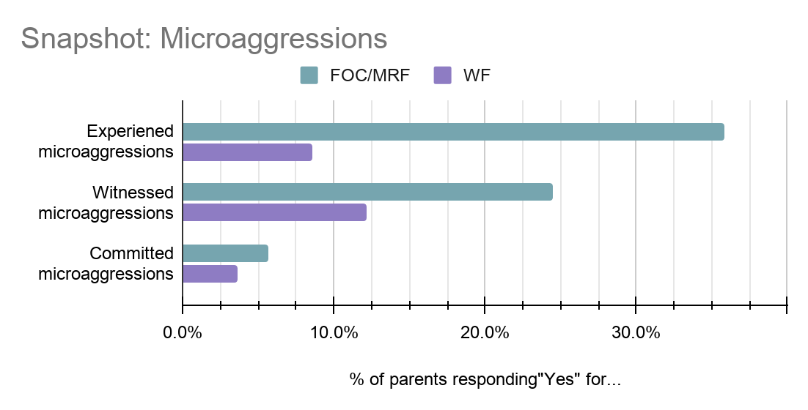
For detailed graphs and comments summary, see Appendix E.

Comments from the Community

From a White Family: “I think it's quite possible that one of us did commit a microaggression, although I hope we did not. It certainly wouldn't have been intentional, but the impact is what's important, not the intent.”

From a Multi-Racial Family: “...witnessed what seemed like a disparaging comment about a parent's hard-to-pronounce name.”

From a Multi-Racial Family: “...had several kids/parents assume I was another parent also of the same race; had kids and parents call my kids the names of other kids also of similar racial background.”
F. Macroaggressions

Q Did any member of your family experience or witness a macroaggression at Pathfinder in the 2019-2020 school year?

Key Points
- A majority of families reported “no” when asked whether they have experienced, witnessed, or committed a macroaggression
- Families of Color and Multi-Racial Families experienced and witnessed many more macroaggressions as compared to White Families
- Comments suggest macroaggressions are not well understood. Here’s a link to a video explaining macroaggressions and what makes them different than microaggressions
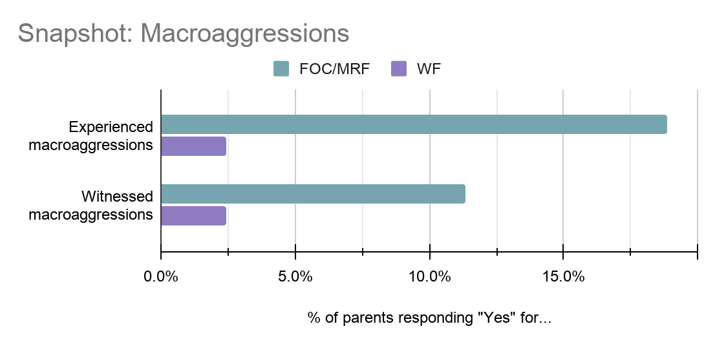
For detailed graphs and comments summary, see Appendix F.

Comments from the Community

From a Multi-Racial Family: “...bullied by another student.”

From a Multi-Racial Family: Comment reported the use of the “n” word by students directed to another child.

From a Multi-Racial Family: Comment reported that a child may have made a Nazi symbol toward another child.

G. Taking Action

Q In your experience, how are each of these constituents embracing and acting on racial equity challenges? School leadership, school admin, teachers, PTSA leadership, parents, students

Key Points
- A majority of families feel all groups are taking action on racial equity challenges by learning and responding
- A majority of families feel teachers are leading change on racial equity challenges
- At least 25% of Families of Color and Multi-Racial Families feel that most groups except teachers are resisting, defensive, or not acting on racial equity challenges

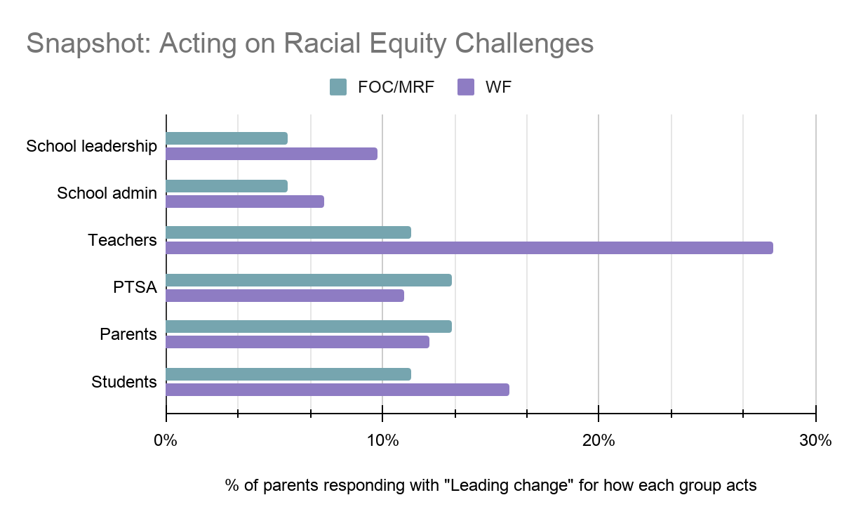
For detailed graphs, see Appendix G.

Comments from the Community
From a White Family: “I would like anti-racism to be more of an active priority for the PTSA.”

From a White Family: “...greater democratic representation of students views & experiences and parent/guardian views and experiences in how the administration operates and makes decisions.”

From a Multi-Racial Family: “...staff/admin talking down to me as if I don't understand how to do things.”
Q What things would you like to see advocated for at Pathfinder to help create a more anti-racist community?
H. Priorities for Action

Key Points
- A majority of families identify three priorities for future action of the options presented:
  - Advocacy for an inclusive curriculum where all kids feel represented
  - Advocacy for ethnic studies class
  - Advocacy for more library books for kids and parents that help change perspectives
- 35% of Families of Color and Multi-Racial Families identified “Help connecting with families similar to yours” as a priority for future action, compared to about 10% of White Families
- Only about 8% of Families of Color and Multi-Racial Families and 5% of White Families reported “I have all the resources I need and feel comfortable taking action on my own”
- Analysis of comments revealed many additional themes for action. By far the most popular category of comment in this section was expanding outreach and increasing diversity in the admissions process
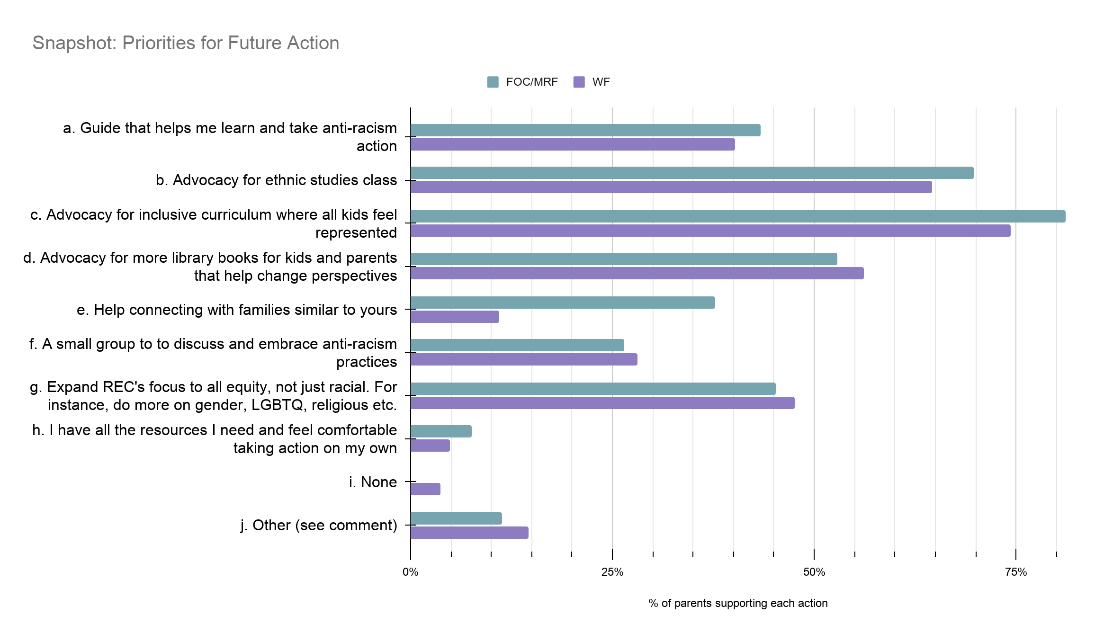
For detailed graphs of priorities by community and comments graph, see Appendix H.

Comments from the Community
From a Multi-Racial Family: “I am happy that some of the curriculum has highlighted black authors and thinkers in the civil rights movement, and some indigenous art and stories as well. I’d love to see this grow even more!”
From a Family of Color: “Since Pathfinder is a choice school and we have a low percentage of POC, I’d like to see POC given priority for 1st pick lottery spots as new students.”
From a White Family: “Hire teachers with diverse backgrounds to represent the diversity in our school and region.”

Observations

Overall, Families of Color and Multi-Racial Families experience Pathfinder as a school and as a community very differently than White Families. Among all families, there is a high level of interest in racial equity and in improving the diversity of the community. REC sees the need for both systemic and individual changes to increase the number of positive experiences reported by Families of Color and Multi-Racial Families at Pathfinder, and thus reduce the disparity in experience reported by Families of Color and Multi-Racial Families and White Families.

The data may at times feel somewhat contradictory to the recommended actions. For instance, families felt most represented in library books but it was also one of the top priorities for future action. Please keep in mind that the list of priorities that families could choose from was limited and while families feel relatively better represented in library books, it may be important for them to see yet more diversity in its collections. REC will make every effort to update and improve REC's questionnaire when it is administered again next year.
Recommended Actions

Beyond the data gathered, REC has benefitted from conversations with several stakeholders including parents, PTSA leadership, RET members, and some members of the Pathfinder staff. The recommendations are based on data gathered through REC’s questionnaire as well as these conversations. They are actionable and designed to help create a more anti-racist community over time. Generally, the actions are presented in order from more systemic changes to more individual changes. Within groups, the items closer to the top would need to happen before items closer to the bottom.

Administration and Staff
Administration and staff are grouped together here though they were distinct in REC’s questionnaire. This is because many of the actions recommended for staff will require administration approval and funding.
- Show welcome and appreciation for Families of Color and Multi-Racial Families
- Hire diverse staff
- Prioritize efforts to create a more inclusive curriculum and incorporate ethnic studies class
- Provide high-quality training on Diversity, Equity, and Inclusion (DEI) and equitable family outreach and engagement to staff
- Do more building level programming similar to the Wednesday Morning Meetings with Roger
- Support increasing the diversity of books and materials in the library and classrooms
- Find ways to incorporate more cultural learning and acknowledgments in a safe and inclusive way
- Support REC’s questionnaire annually by sending it out so more families have the opportunity to respond
- Provide more inclusive representation in the hallway (when buildings are open)
- Increase awareness of opportunities to be a stakeholder in decisions (e.g. Building Leadership Team)
- Consider ways to involve all students in taking action towards anti-racism
- Create targeted outreach and engagement in the West Seattle community and beyond to increase awareness of Pathfinder as an option school. Communicating the DEI actions broadly is a long term tactic that may encourage diversity at Pathfinder
- Advocate for a change in the Pathfinder lottery criteria in order to prioritize the selection of students from diverse communities

PTSA
- Increase awareness of PTSA by sharing roles and open positions broadly
- Make DEI a priority in officer recruitment and training
- Improve communication and engagement with families - many don’t know all the great things the PTSA does
- Allocate more funds towards helping with top priorities and other items that create systemic change (more diverse library books, funds for inclusive curriculum materials, training, etc)
- Move towards more community engagement in creating the PTSA budget
- Create future events with DEI in mind. Find ways to acknowledge and celebrate other cultures
- Continue supporting REC’s questionnaire and using the results as a way of gauging progress

REC
- Administer REC's questionnaire at the end of each school year to gauge progress on a regular basis
- Distribute REC's questionnaire report widely showing both progress made and further work needed
- Consult frequently on racial equity issues for the PTSA
- Advocate for racial equity issues throughout all decision-making processes in the Pathfinder community
- Collaborate with RET and other groups as needed

Families
- Connect with REC by joining the site page for resources. The page is on the new PTSA website at: https://www.pathfinderk8ptsa.org/groups/racial-equiity-committee/
- Join REC’s anti-racism pledge and action guide when it is published before the end of the school year. This is a way for families to commit to racial equity and take several specific actions. Suggested actions include learning through resources like videos and books for adults and kids, opportunities for activism and investing in Black, Indigenous and People of Color communities
- Commit to reading this report in its entirety and taking REC’s questionnaire annually
- Join the PTSA
- Consider nominating yourself or someone else for PTSA executive board and other chair positions
- Familiarize yourselves with the amazing resources already provided in the Pathfinder library
- Reach out to someone in the community you don’t know — make a new connection
Acknowledgements
REC appreciates each and every family that submitted responses to REC’s questionnaire. We could not have completed this work without you, your thoughtful comments, and your courage to share difficult and often painful personal and family experiences. Thank you for your candor and bravery.

REC also wishes to thank the many volunteers who contributed to the data collection, collating, review, analysis, and drafting work in this Report. In particular, REC thanks Christine Bhatkar, Sarah Schieron, Andri Kofmehl, Radhika Makhija, Shannon McDonald, Crys Aguon, Anne Bradfield, Rumina Killeen, Aaron Norikane, Noemi Ho, Vanessa Brown Sweeney, AnaLuisa Orantjes-Seijo, Sharon English, and Lisa Pascuzzi.

REC is grateful to our families for their patience and support - especially our children who waited many hours while we worked on REC’s questionnaire creation, analysis, and report instead of playing with them.
Appendix A - Feel Welcomed

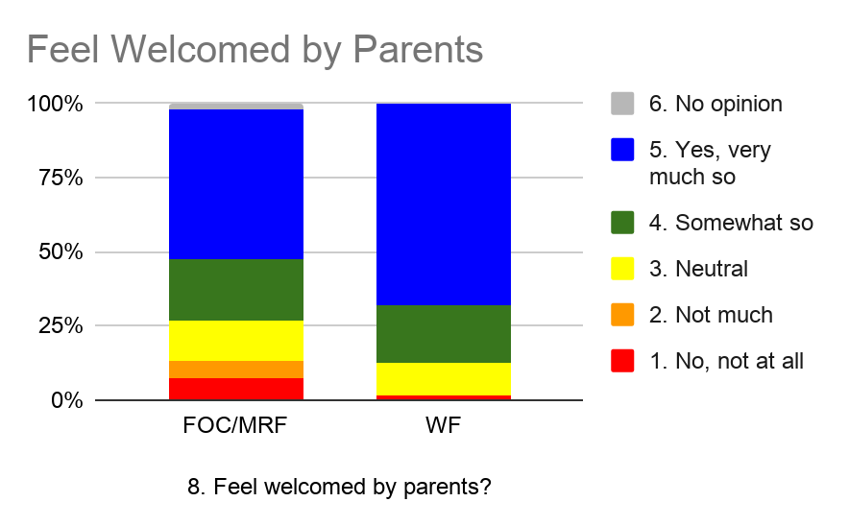
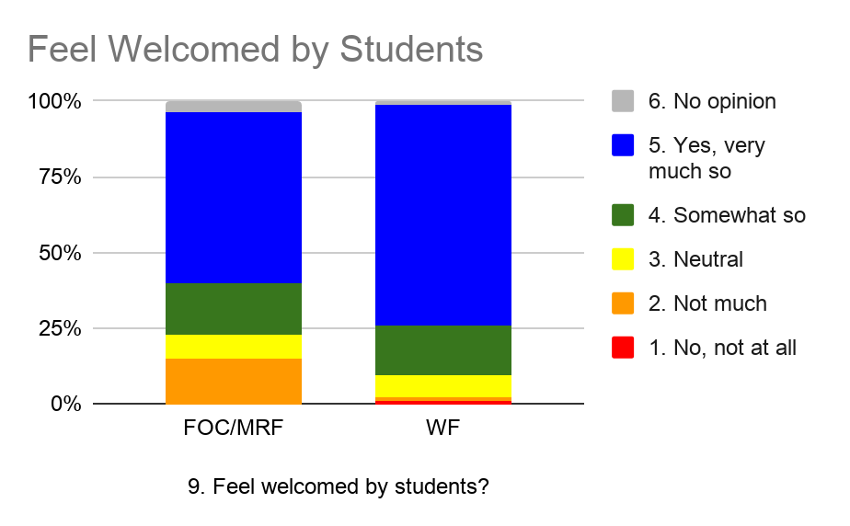
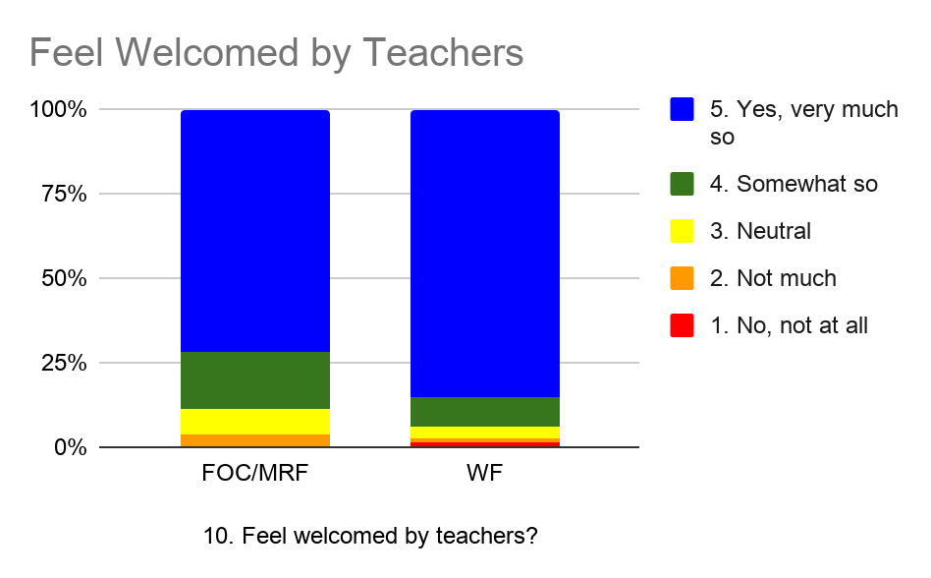
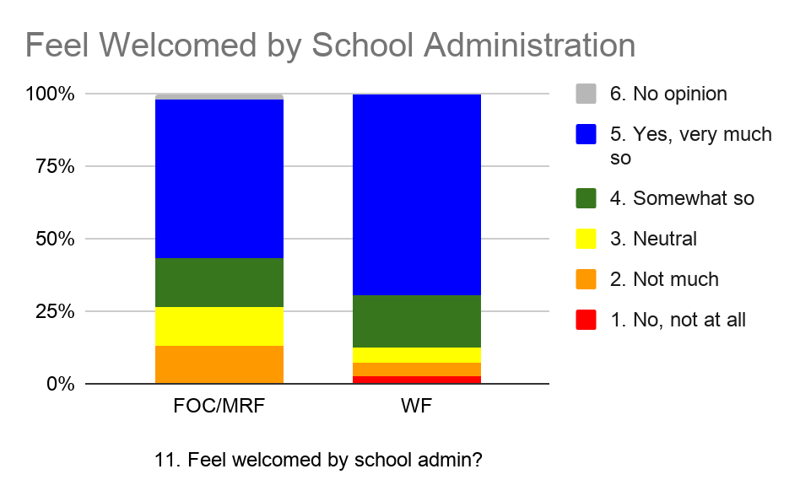

Appendix B - Feel Belonging

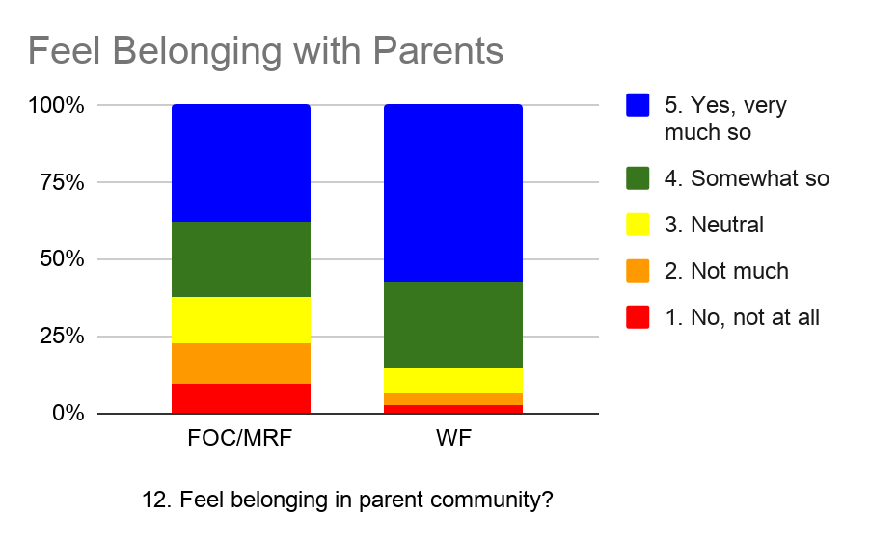
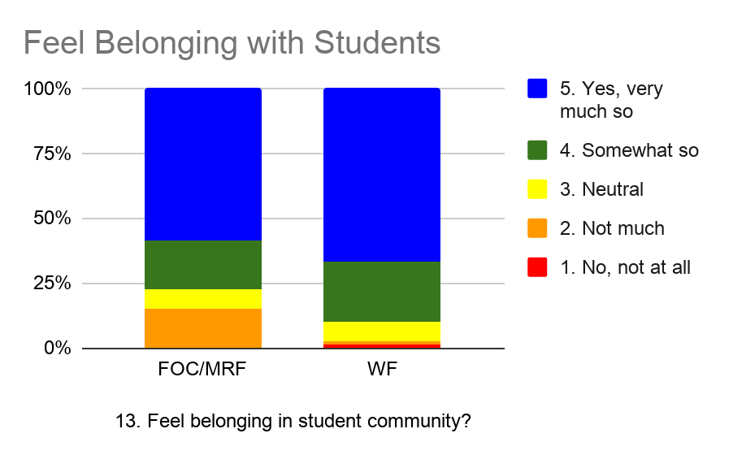
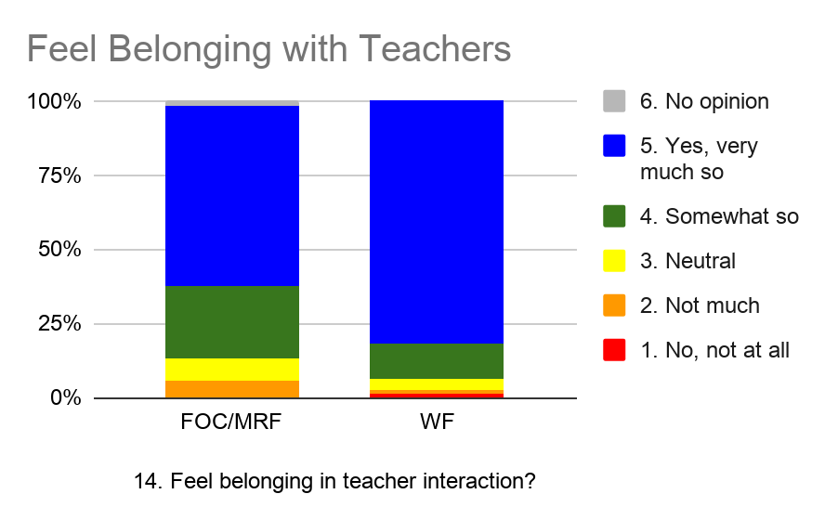
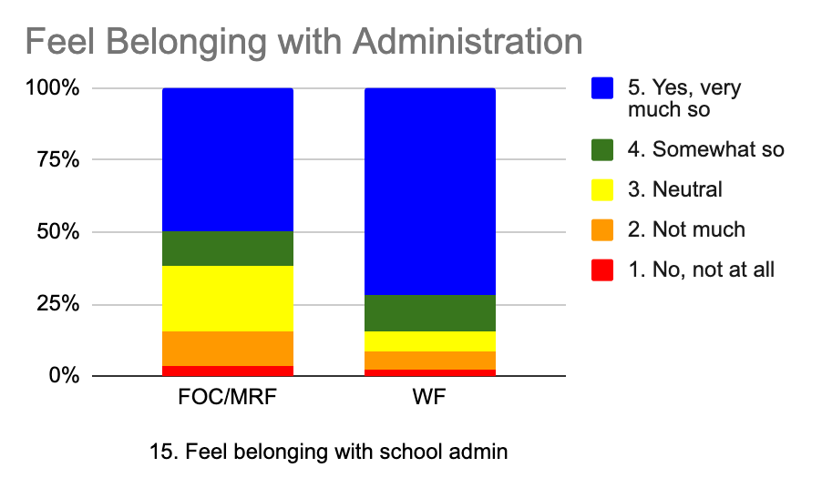

Appendix C - Feel Represented

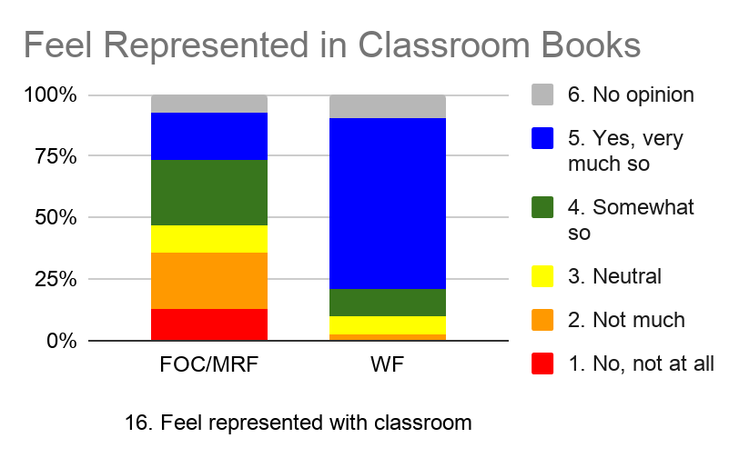
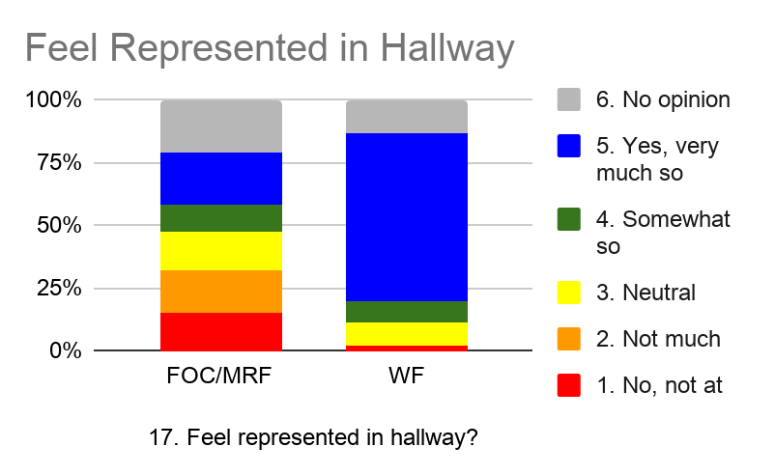
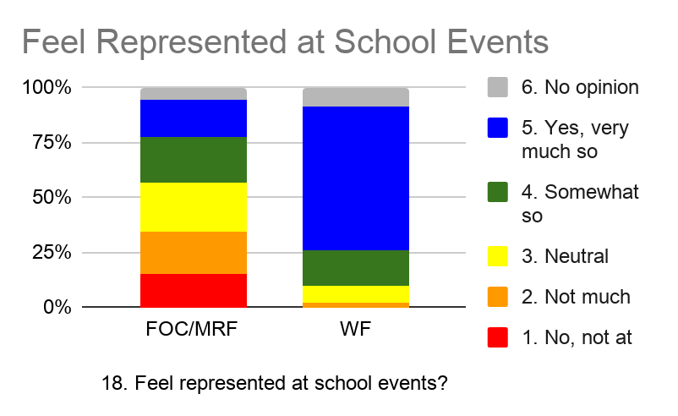

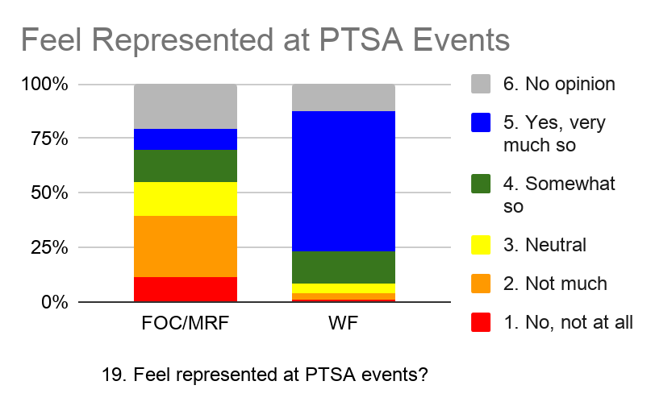
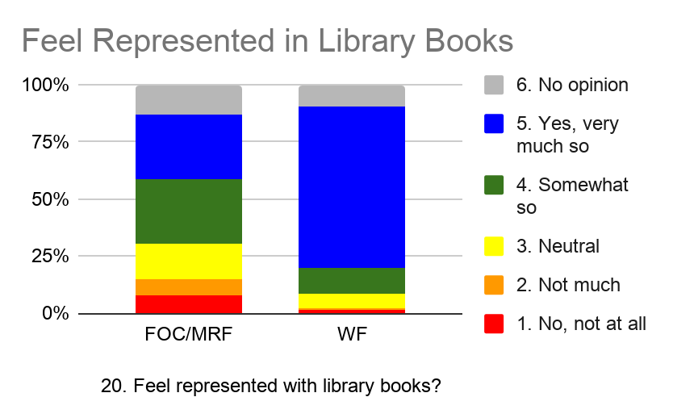
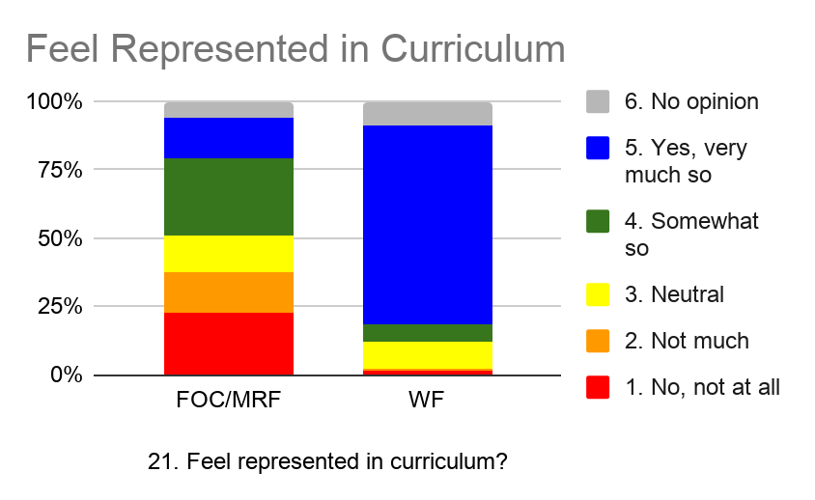

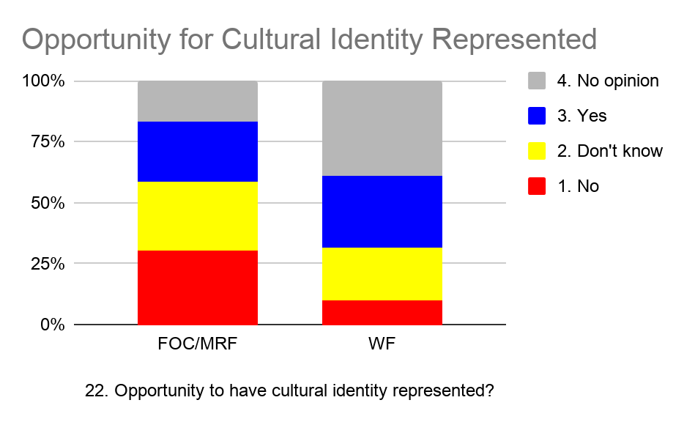
Appendix D - Opportunities for Cultural Identity
to be Represented, Shared or Celebrated
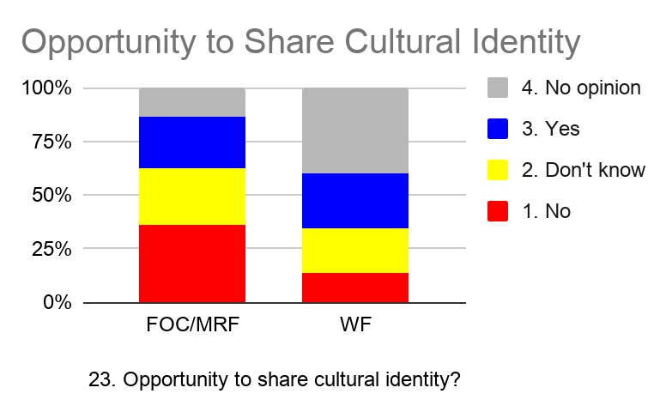
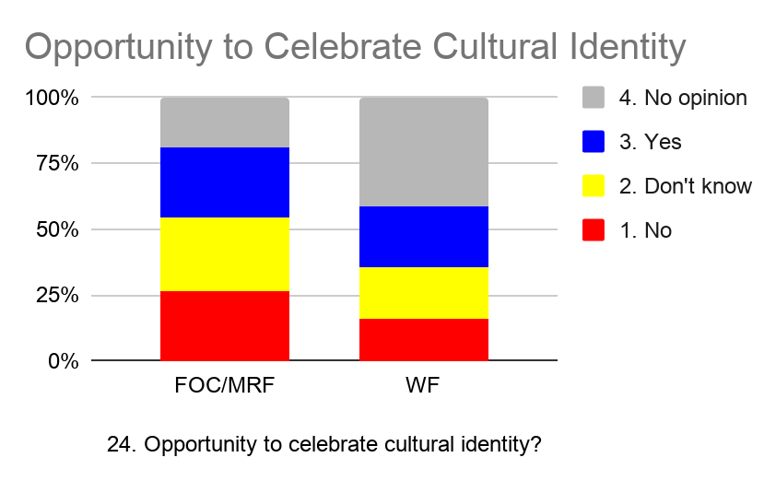
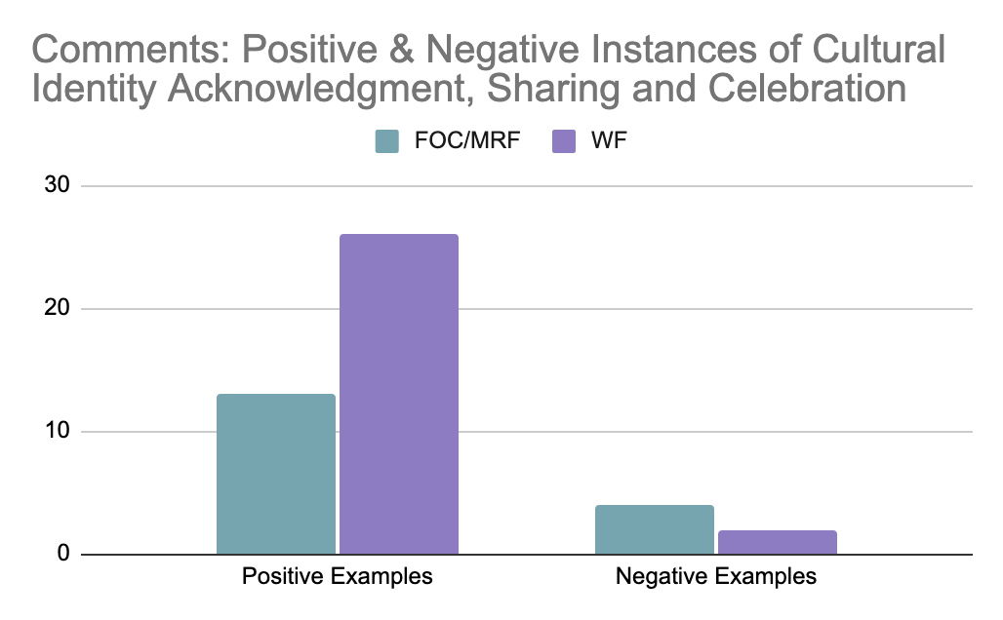

Comments Summary
(Number of Repeated Responses Indicated in Parentheses)
Positive Instances - FOC/MRF | Positive Instances - WF
- Student Sharing in Classroom (5)  - Roger Monday Morning Meeting  - Chinese Program  - Bilingual/Cultural Books in Classroom  - Martin Luther King, Jr. Celebration  - International Potluck  - Hanukkah Explained  - Black Lives Matter Supported  - Lunar New Year | - Student Sharing in Classroom (2)  - Roger Monday Morning Meeting  - Chinese Program  - Bilingual/Cultural Books in Classroom  - Whiteness Always Acknowledged (16)  - Elders Luncheon (2)  - Family and Community Projects  - LGBTQ Night  - Teachers Representative of Family
Negative Instances - FOC/MRF | Negative Instances - WF
- No Cultures are Celebrated  - Hanukkah Not Acknowledged  - No Opportunity to Share Culture  - Family Treated as Foreign/”Immigrant” | - No Cultures are Celebrated  - Hanukkah Not Acknowledged
Appendix E - Microaggressions

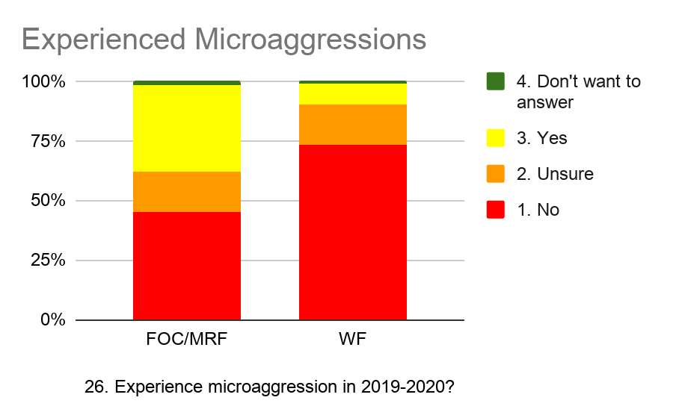
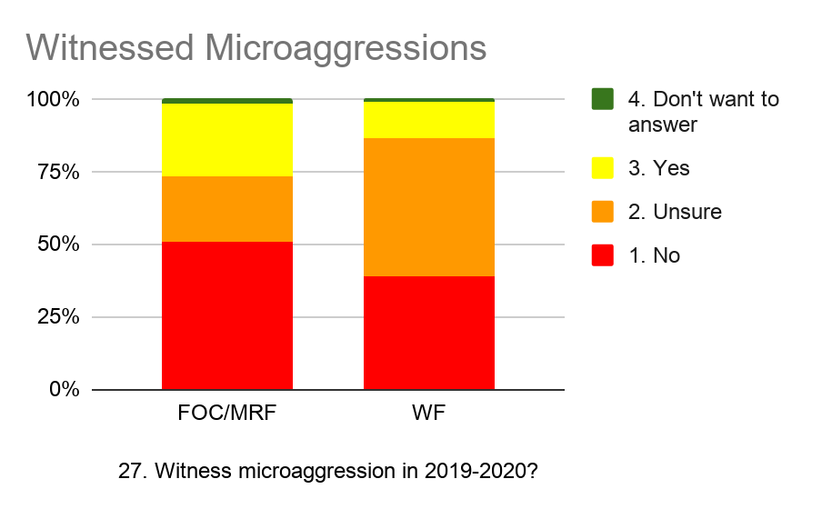
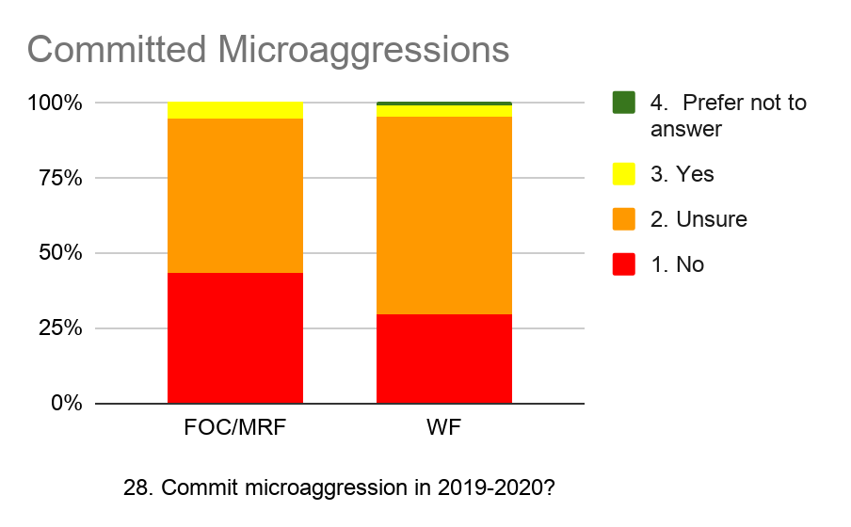
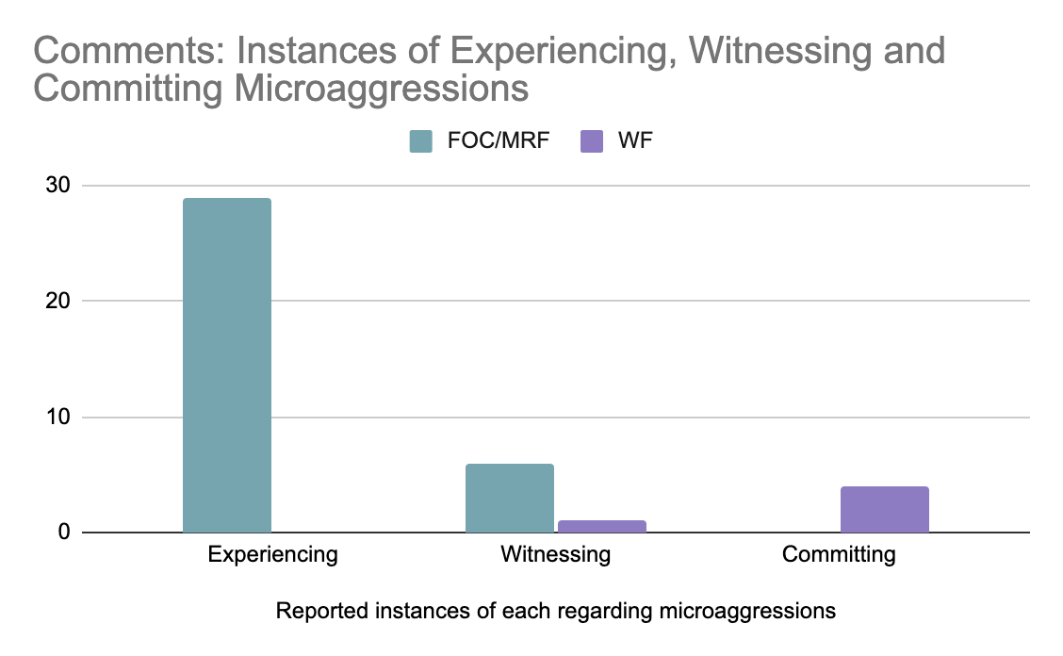

Comments Summary
(Context of Microaggression, Actor Noted in Parentheses; All Examples Taken from Comments)
Experienced by FOC/MRF | Experienced by WF
- FOC Student Experienced Feeling Uncomfortable During Teaching of Civil Rights Unit (Classroom Experience, Unknown)  - Scolding MRF Parent and MRF Student as “Teaching Moment” for Group of WF Parent Onlookers (Group Experience, Administration)  - FOC/MRF Experiences and Backgrounds at Majority White School Unacknowledged (Individual Experience, Environment)  - Unwanted Attention Concerning FOC Student Appearance (e.g. comments about and requests to touch hair) (Individual Experience, Student)  - Questioning FOC Student Parentage and Legitimacy of MRF Parent-Child Relationship (Individual Experience, Student)  - Cultural Stereotyping (e.g. assuming FOC student is “Chinese” or has a preference for rice) (Individual Experience, Student)  - WF Student Denigrating Friendship with MRF Student Because of Skin Color (Individual Experience, Student)  - Public Mispronunciation of Names, Joking At Unfamiliar Names (Group Experience, Administration)  - Confusion and/or Misidentification of Same-Race FOC/MRF Parents (Individual Experience, Parent)  - Confusion and/or Misidentification of Same-Race FOC/MRF Students (Individual Experience, Parent, Student)  - Patronizing Administration Assistance and Assumption of Incompetence of FOC/MRF Parents (Individual Experience, Administration)  - N-Word Used by Students (Individual Experience, Student)  - Absence of Cultural Representation (e.g. AAPI) (Individual Experience, Building/Environment)  - Absence of Curriculum Concerning Systemic Racism (Individual Experience, Curriculum)  - Confusion and/or Misidentification of FOC/MRF Students as WF Students (Individual Experience, Parents and Students)  - Assumption FOC/MRF Students Represent Physical Threat (Individual Experience, Parents) | - Cultural Stereotyping (e.g. assuming WF parent is “Russian”)
Witnessed by FOC/MRF | Witnessed by WF
- Differential Treatment of FOC and MRF Parents When Same Behavior By WF Parents Was Excused (Group Experience, Administration)  - Public Mispronunciation of Names, Joking At Unfamiliar Names (Group Experience, Administration)  - Policing of FOC Parenting by WF Parents (Group Experience, Parents)  - Conspicuous Noticing of FOC and MRF Students by WF Parents as “Behavior Problems” (Group Experience, Parents)  - Unwanted Touching of FOC Student by WF Student (Classroom Experience, Student) | - WF Parent Declining Assistance from FOC/MRF Parent Because “Uncomfortable” Receiving Aid (Individual Experience, Parent)
Committed by FOC/MRF | Committed by WF
No comments were reported. | - Acknowledgment of Possible Past Unknown Microaggressions (Individual Experience, Parent)  - Unwanted Attention Concerning Personal Appearance (e.g. Hair) (Individual Experience, Student)

Appendix F - Macroaggressions
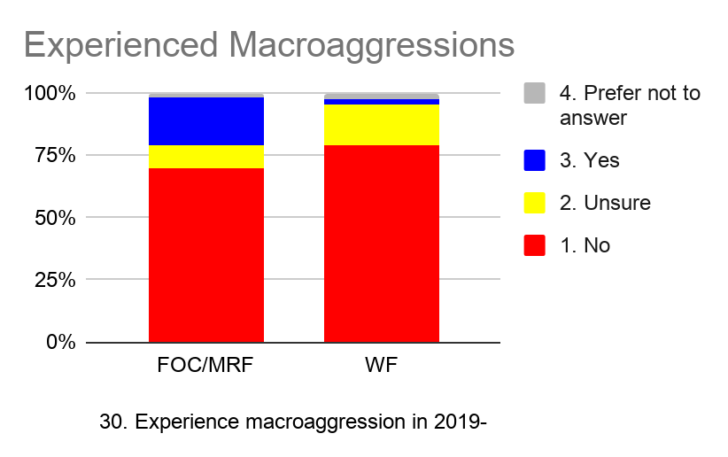
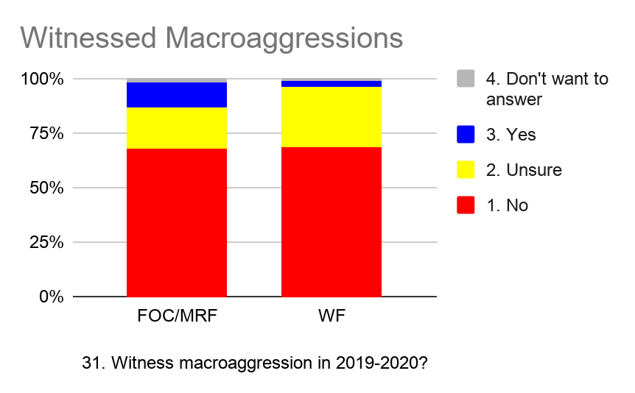

Comments Summary
(Context of Macroaggression, Actor Noted in Parentheses; All Examples Taken from Comments )
Experienced by FOC/MRF | Experienced by WF
- Overt Mistreatment of Asian American FOC Parents and Students, Attributing Blame for COVID-19 (Individual Experience, WF and FOC Parents and Students)  - Overt Disparaging Comments about MRF Student Country of Origin (Individual Experience, Student)  - Overt Disparaging Comments about MRF Student’s Parents (e.g. “Black Absentee Father”) (Individual Experience, Student)  - Targeting Younger MRF Students for Bullying on Playground (Group Experience, Student)  - Targeting MRF Female Students for Bullying by WF Male Students in Connection with Sports (Group Experience, Student)  - Targeting FOC for Bullying Because “Hispanic” (Individual Experience, Student)  - Overt Nazi Gesture, Profanity Targeting MRF Student Because “Black” (Individual Experience, Student)  - Generalized Hostility Directed to FOC Students in Classroom Environment (Individual Experience, Students)  - Overt Reliance on Cultural Stereotyping to Denigrate MRF/FOC Parents and Students (e.g., “Dragon Lady”, “Tiger Mom”, “Black Absentee Father”) (Group Experience, Administration, Parents) | - No comments were reported.
Witnessed by FOC/MRF | Witnessed by WF
- No comments were reported. | - No comments were reported.

Appendix G - Taking Action

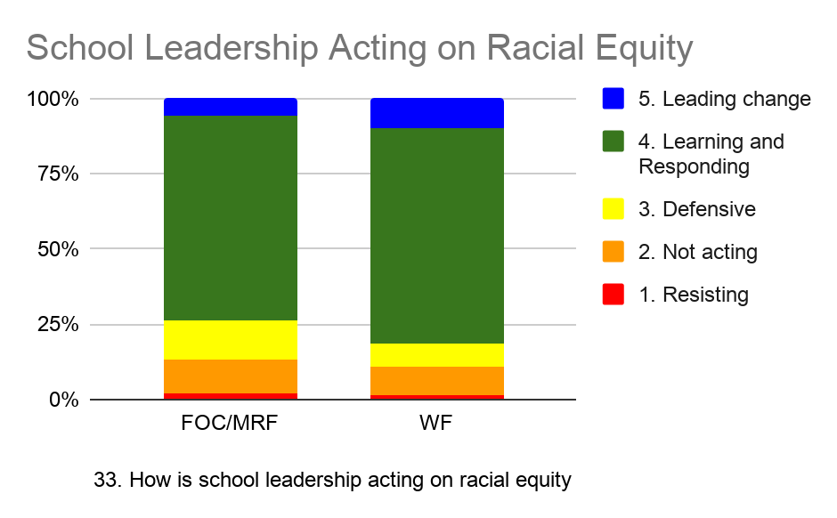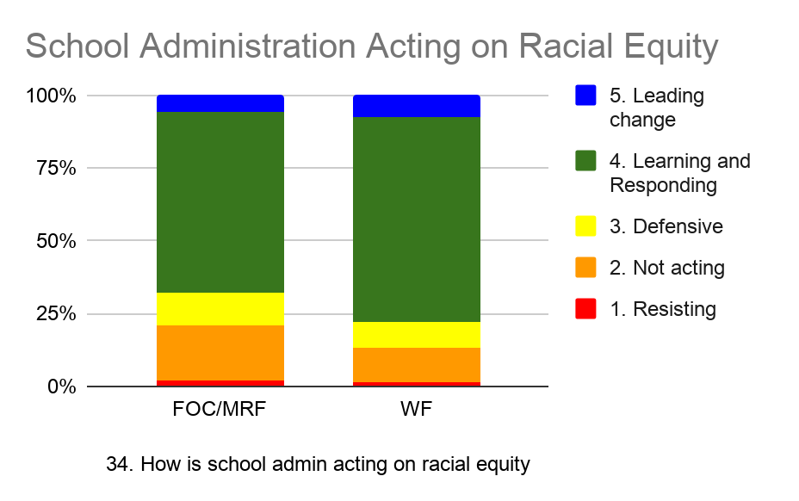
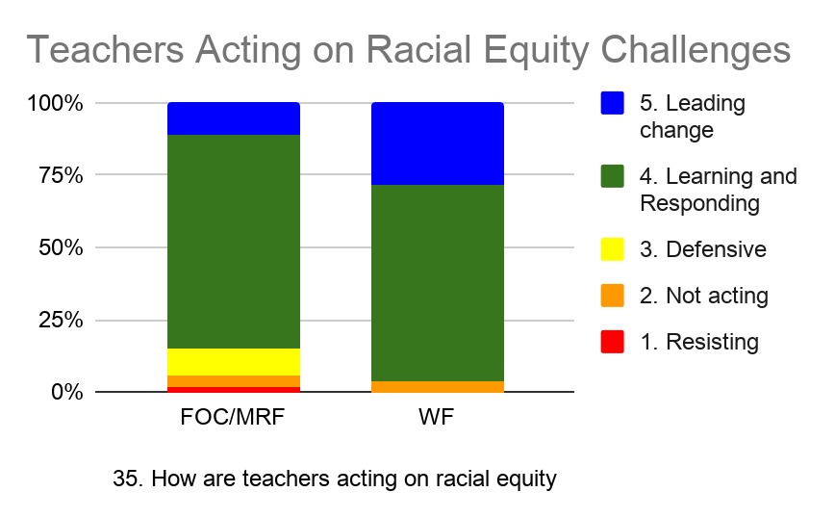
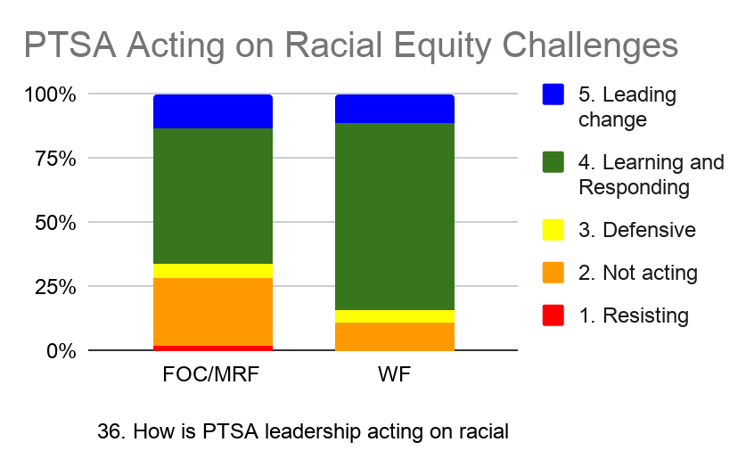
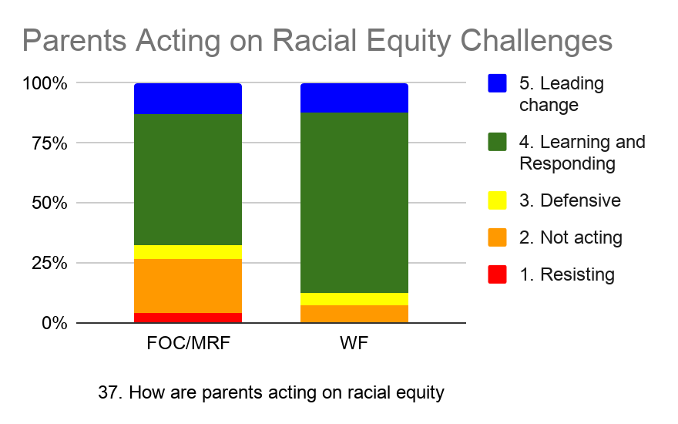
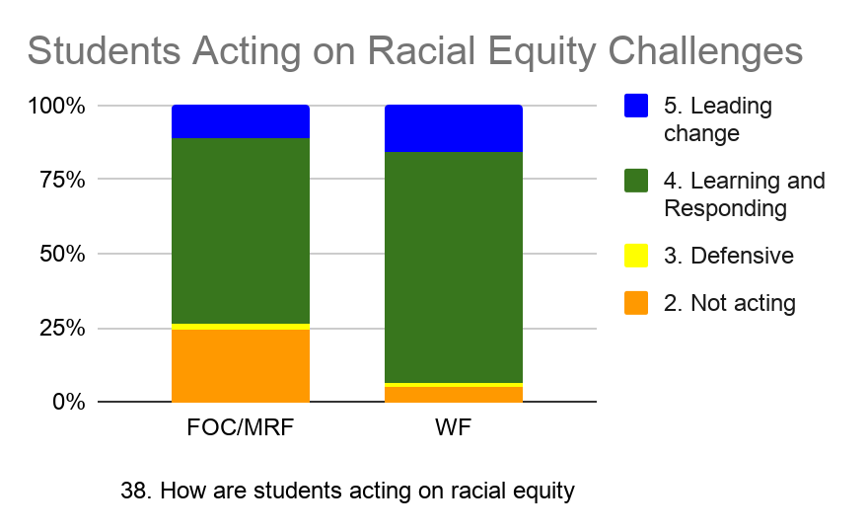

Priorities for future action broken down by racial groups
Appendix H - Priorities for Future Action
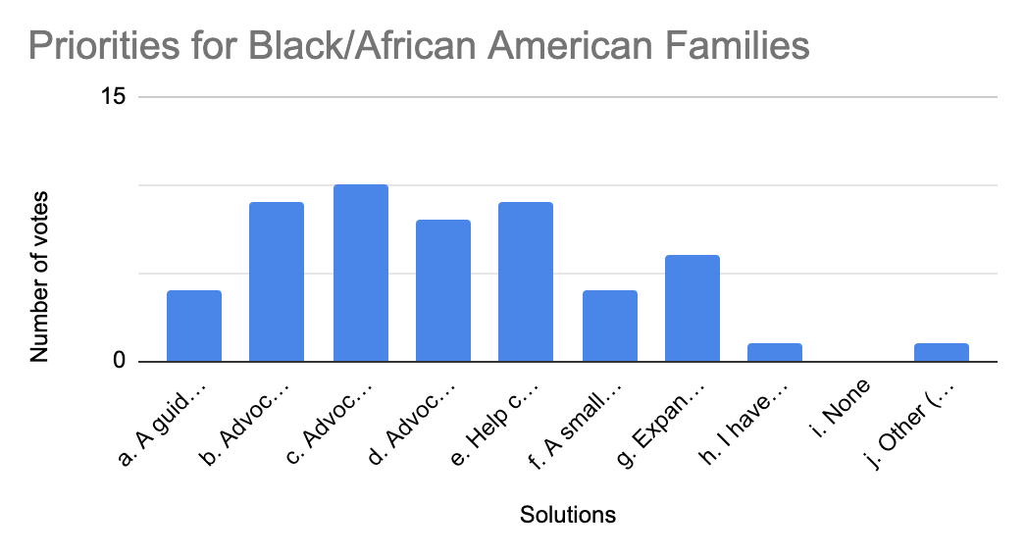

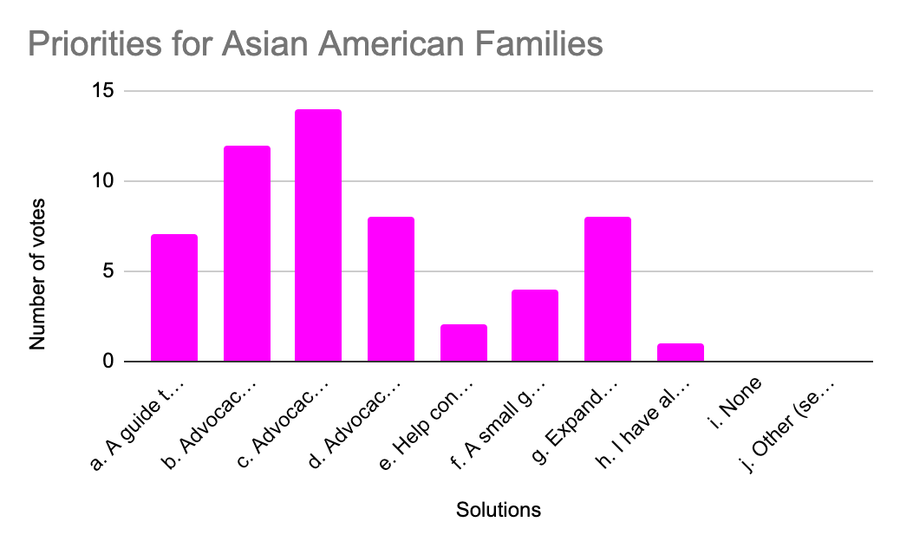

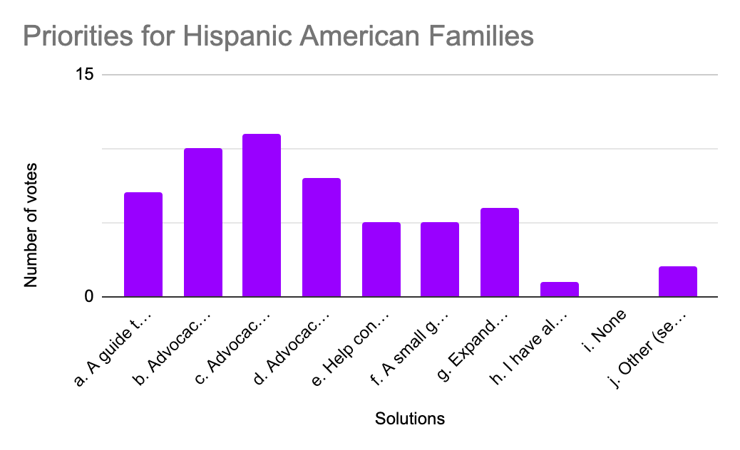

Comments Analysis
The comments in “Other” option and “Other Comments” were grouped and analyzed for themes. The graph below shows the frequency of themes that emerged.

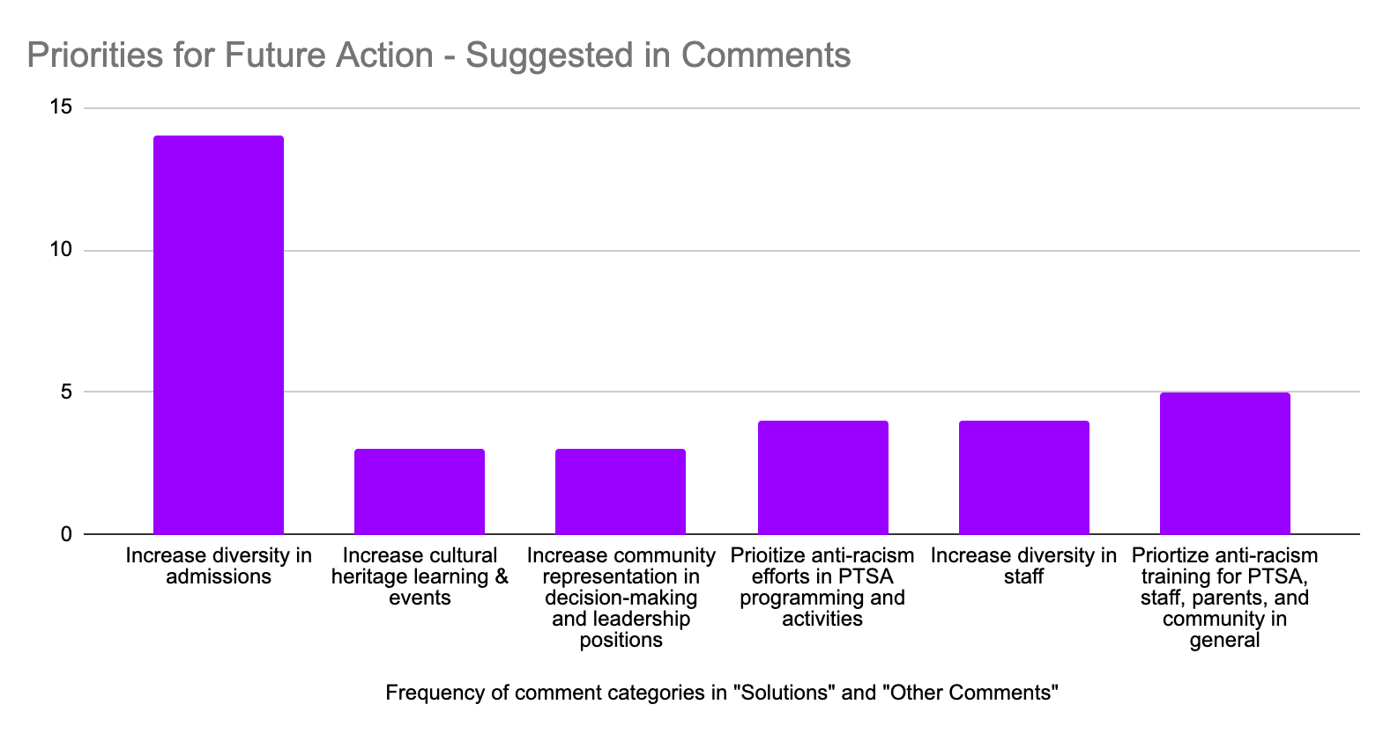

Appendix I - Demographic
Data for Schools in Seattle

Demographic breakdown of all students in Seattle Public Schools
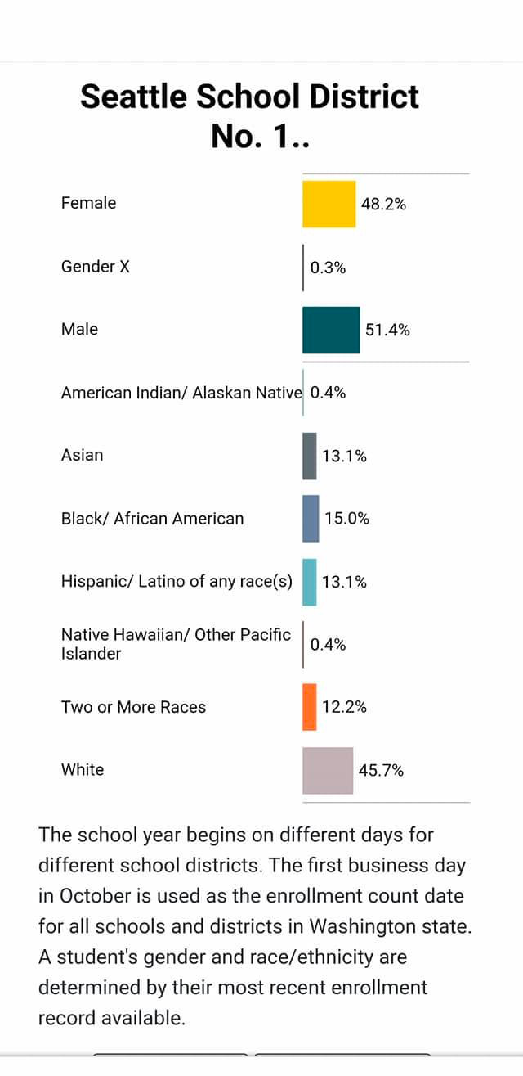

Demographic breakdown for Pathfinder K-8 and neighboring school Louisa Boren STEM K-8
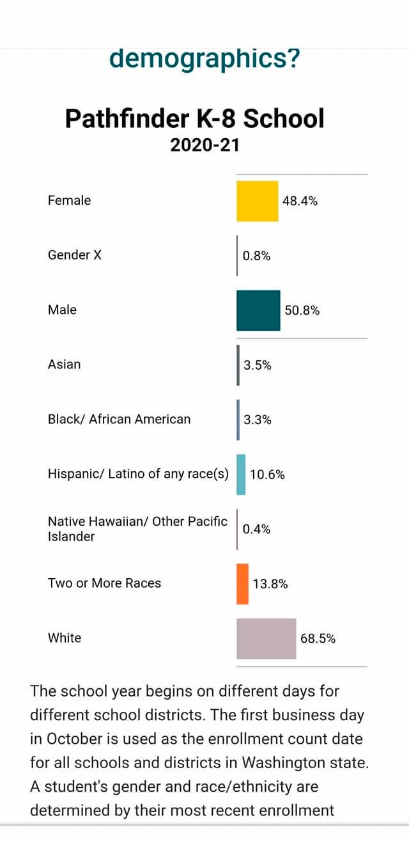
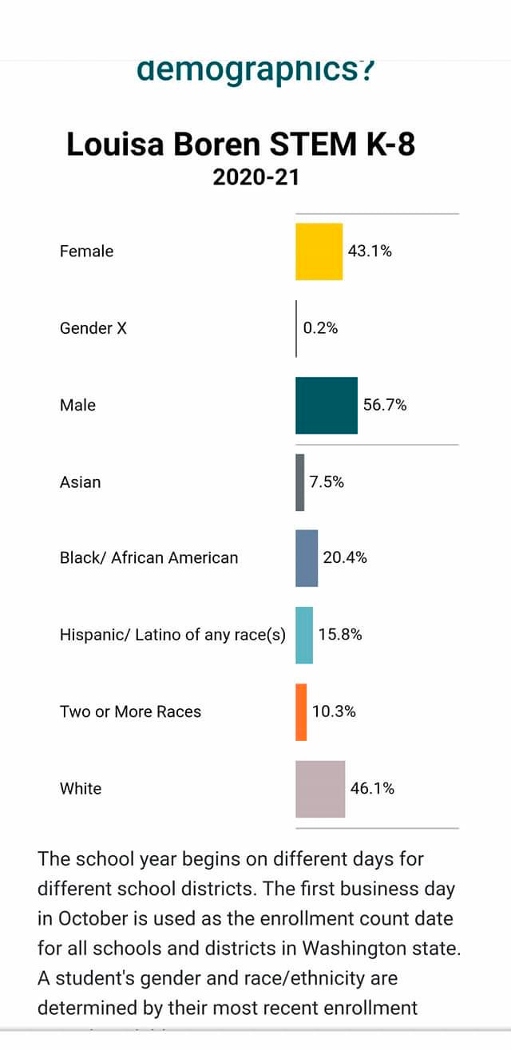

Appendix J - Racial Equity Questionnaire

List of questions included in the questionnaire sent December 2020

1. How do you identify yourself and family members racially? Check all that apply, for instance if your family has mixed racial heritage.

2. What grades did your children attend at Pathfinder in the 2019-2020 school year?

3. Do you and your family feel welcomed?
- In the parent community
- In the student community
- By teachers
- By school administration

4. Do you and your family feel like you belong?
- In the parent community
- In the student community
- In interaction with teachers
- In interaction with school administration?

5. Does your family feel racially and culturally represented through the following at Pathfinder? *
- Entrance hallway
- Books in classroom
- Books in library
- In the curriculum
- School events
- PTSA events

6. Did you family have an opportunity to
- Have your cultural identity acknowledged?
- Have your cultural identity shared?
- Have your cultural identity celebrated?

7. If you answered "yes" to any part of question 6, please provide examples.

8. Did any member of your family experience a microaggression in the school year 2019-2020? *

9. Did any member of your family witness a microaggression in the school year 2019-2020? *

10. We often commit these microaggressions unintentionally. Did any member of your family unintentionally commit a microaggression in the 2019-2020 school year?

11. If you answered yes to any of the 3 questions #8 to #10 above , and feel able to, please give examples of when you or your family members experienced, witnessed, or unintentionally committed these microaggression(s).

12. Did any member of your family experience a macroaggression at Pathfinder in the 2019-2020 school year?

13. Did any member of your family witness a *macroaggression* in the school year 2019-2020?

14. If you answered yes to #12 and/or #13, and feel able to, please give examples.

15. In your experience, how are each of these constituents embracing and acting on racial equity challenges? *
- School leadership
- School admin
- Teachers
- PTSA leadership
- Parents
- Students

16. What thing/things would you like to see advocated for at Pathfinder to help create a more anti-racist community and one in which everyone feels belonging? Check all that apply. *
- A guide that helps me learn and take more anti-racism action
- Advocacy for ethnic studies class
- Advocacy for inclusive curriculum where all kids feel represented
- Advocacy for more library books for kids and parents that help change perspectives Help connecting with families similar to yours
- A small group to to discuss and embrace anti-racism practices
- Expand REC's focus to all equity, not just racial. For instance, do more on gender, LGBTQ, religious etc.
- I have all the resources I need and feel comfortable taking action on my own
- None

17. Is there anything we are missing and/or that you would like us to know?

Appendix K - Glossary of Terms
Related to Racism*

Racism
The marginalization and/or oppression of people of color based on a socially constructed racial hierarchy that privileges white people.

Structural Racism
A system in which public policies, institutional practices, cultural representations, and other norms work in various, often reinforcing ways to perpetuate racial group inequity. It identifies dimensions of our history and culture that have allowed privileges associated with “whiteness” and disadvantages associated with “color” to endure and adapt over time. Structural racism is not something that a few people or institutions choose to practice. Instead it has been a feature of the social, economic and political systems in which we all exist.

Systemic Racism
Similar to structural racism. The systematic distribution of resources, power and opportunity in our society to the benefit of people who are white and the exclusion of people of color.

Anti-Racism
Anti-racism is a form of action against racism and the systemic racism and oppression of marginalized groups. Being antiracist is based on the conscious efforts and actions to provide equitable opportunities for all people on an individual and systemic level.

Equity
Racial equity refers to what a genuinely non-racist society would look like. In a racially equitable society, the distribution of society’s benefits and burdens would not be skewed by race. In other words, racial equity would be a reality in which a person is no more or less likely to experience society’s benefits or burdens just because of the color of their skin.

Diversity
This is the practice or quality of including or involving people from a range of different social and ethnic backgrounds and of different genders, sexual orientations, etc.

Inclusion
The policies and practices in which different groups or individuals having different backgrounds are culturally and socially accepted and welcomed, and equally treated. Inclusion is having a sense of belonging.

* Definitions courtesy of Anti-Defamation League and the Aspen Institute

